**Anders Concepts -**

* **Hash -**

Hash is basically **SHA256** encrypted key(code) for the data entered by the user in the block(mentioned as **‘DATA:’** in the below figure).

SHA256 is used for one-way encryption of your data.

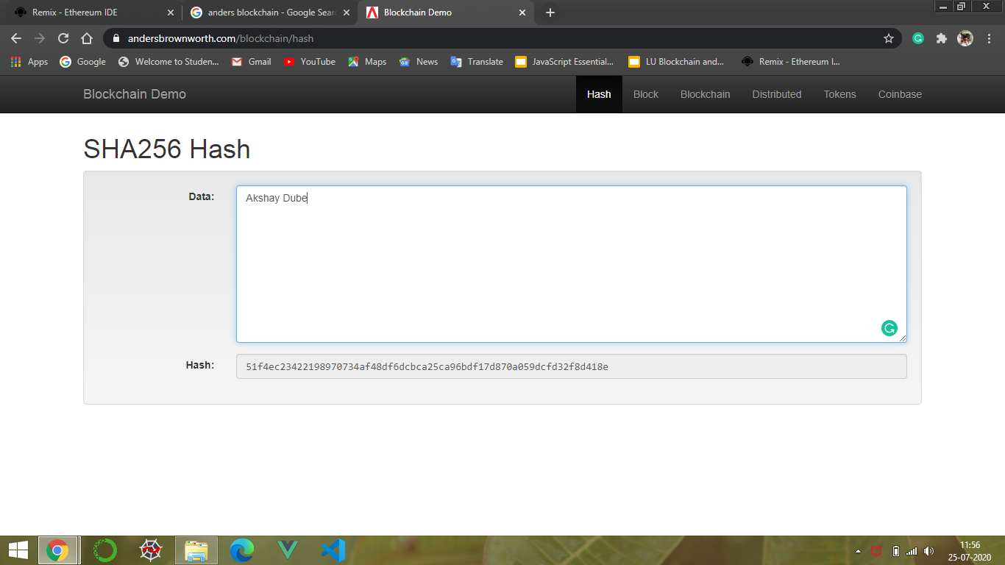

Here, **“51f4ec23422198970734af48df6dcbca25ca96bdf17d870a059dcfd32f8d418e”** is the Hash key developed/encrypted for the data entered by the user. For instance, the entered data above to be encrypted is **“Akshay Dube”.**

* **Block -**

A block basically is the first of the initial cell of a blockchain. A block comprises of elements mentioned as below -

1. Block No. - This represents the serial number of the block. For Eg - 1,2,3…..etc.
2. Nounce/Mining Key - This is a numerical value that represents the result of the complex problem that is generated in blockchain timely.

It always has to provide a HASH key having ‘N’ Number of “0’s” at its beginning.

1. Data - It is a storage area for the data the user wishes to secure in a blockchain network.
2. Hash - Hash is basically **SHA256** encrypted key(code) for the data entered by the user in the block(mentioned as **‘DATA:’** in the below figure).

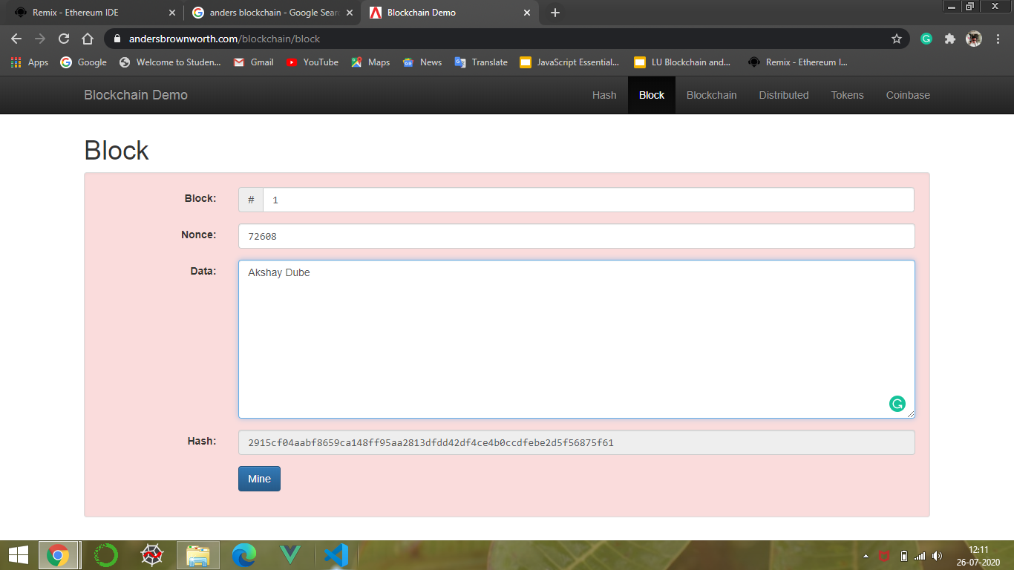

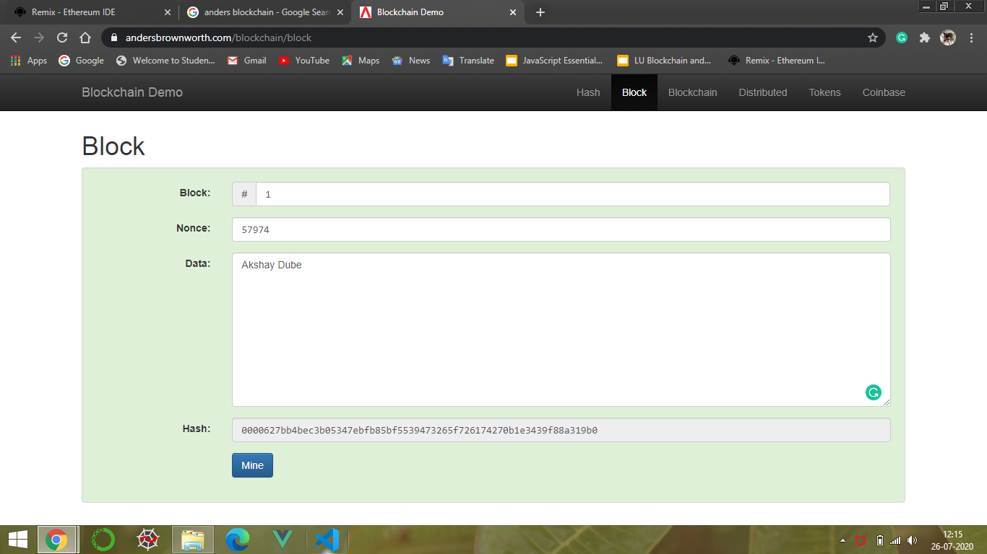

* **Blockchain -**

This is a series of blocks as explained above to form a series of encryption for the data in the decentralised having many nodes to get the data verified at any node.

This makes the process -

1. Verifiable
2. Unchangeable
3. Tamper - Proof
4. Immutable

**The first block of any blockchain is also known as “Genesis Block”.**

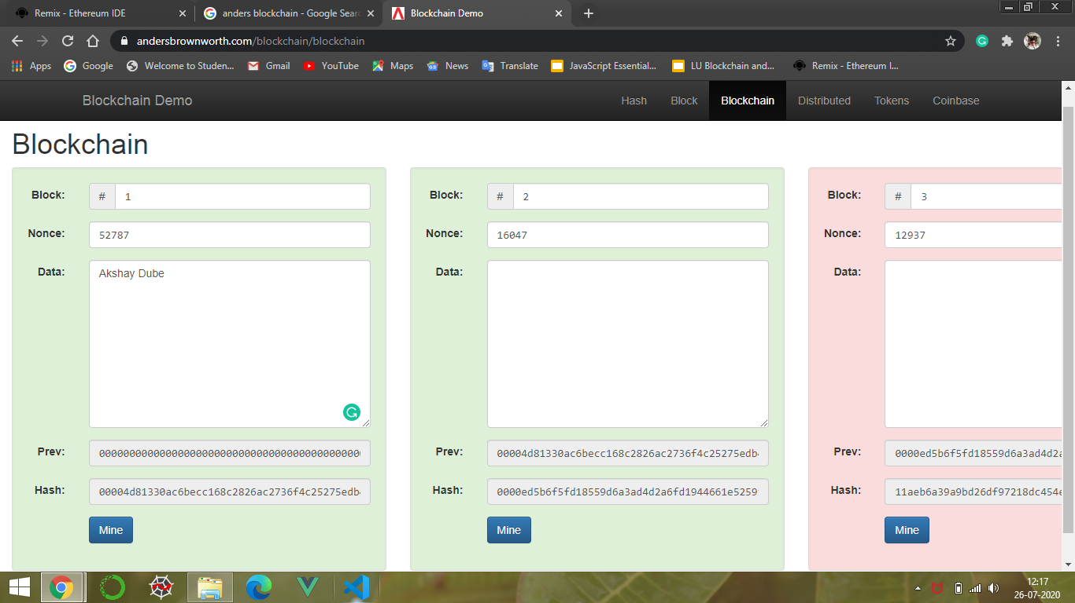

* **Distributed Blockchain -**

**This is basically the multiple copies of blockchain inside a single blockchain.**

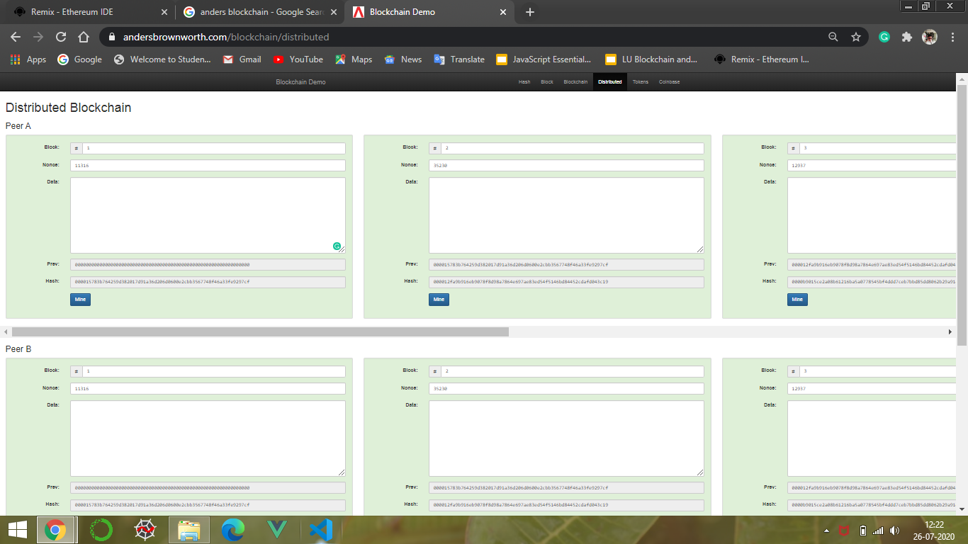

**In this example - Peer B is the copy of Peer A, Thus forming a distributed network to avoid data tempering.**

* **Tokens -**

Tokens are basically a blockchain network/distributed Blockchain network which just keeps the track of money-movements Or just the transactional information of a balance sheet. It doesn’t keep track of the balance of money with each entry registered inside any block of a token.

It helps in backtracking in case any alteration is done to the data wherein the entry of money transaction has been altered.

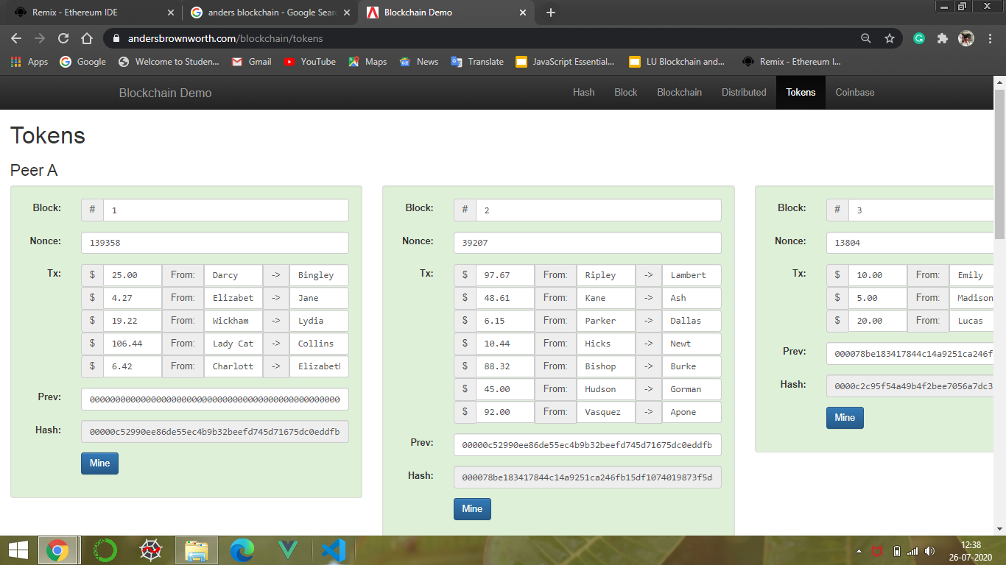

* **Coinbase -**

Coinbase is an advancement to Tokens. Here, the tag coinbase represents the balance amount of the person has with him/her. Thus it becomes possible for us to track that particular user is not having transactions beyond is limit of ownership of the finances.